Figure 1. Scoring on Holes 2 and 18 by Year. 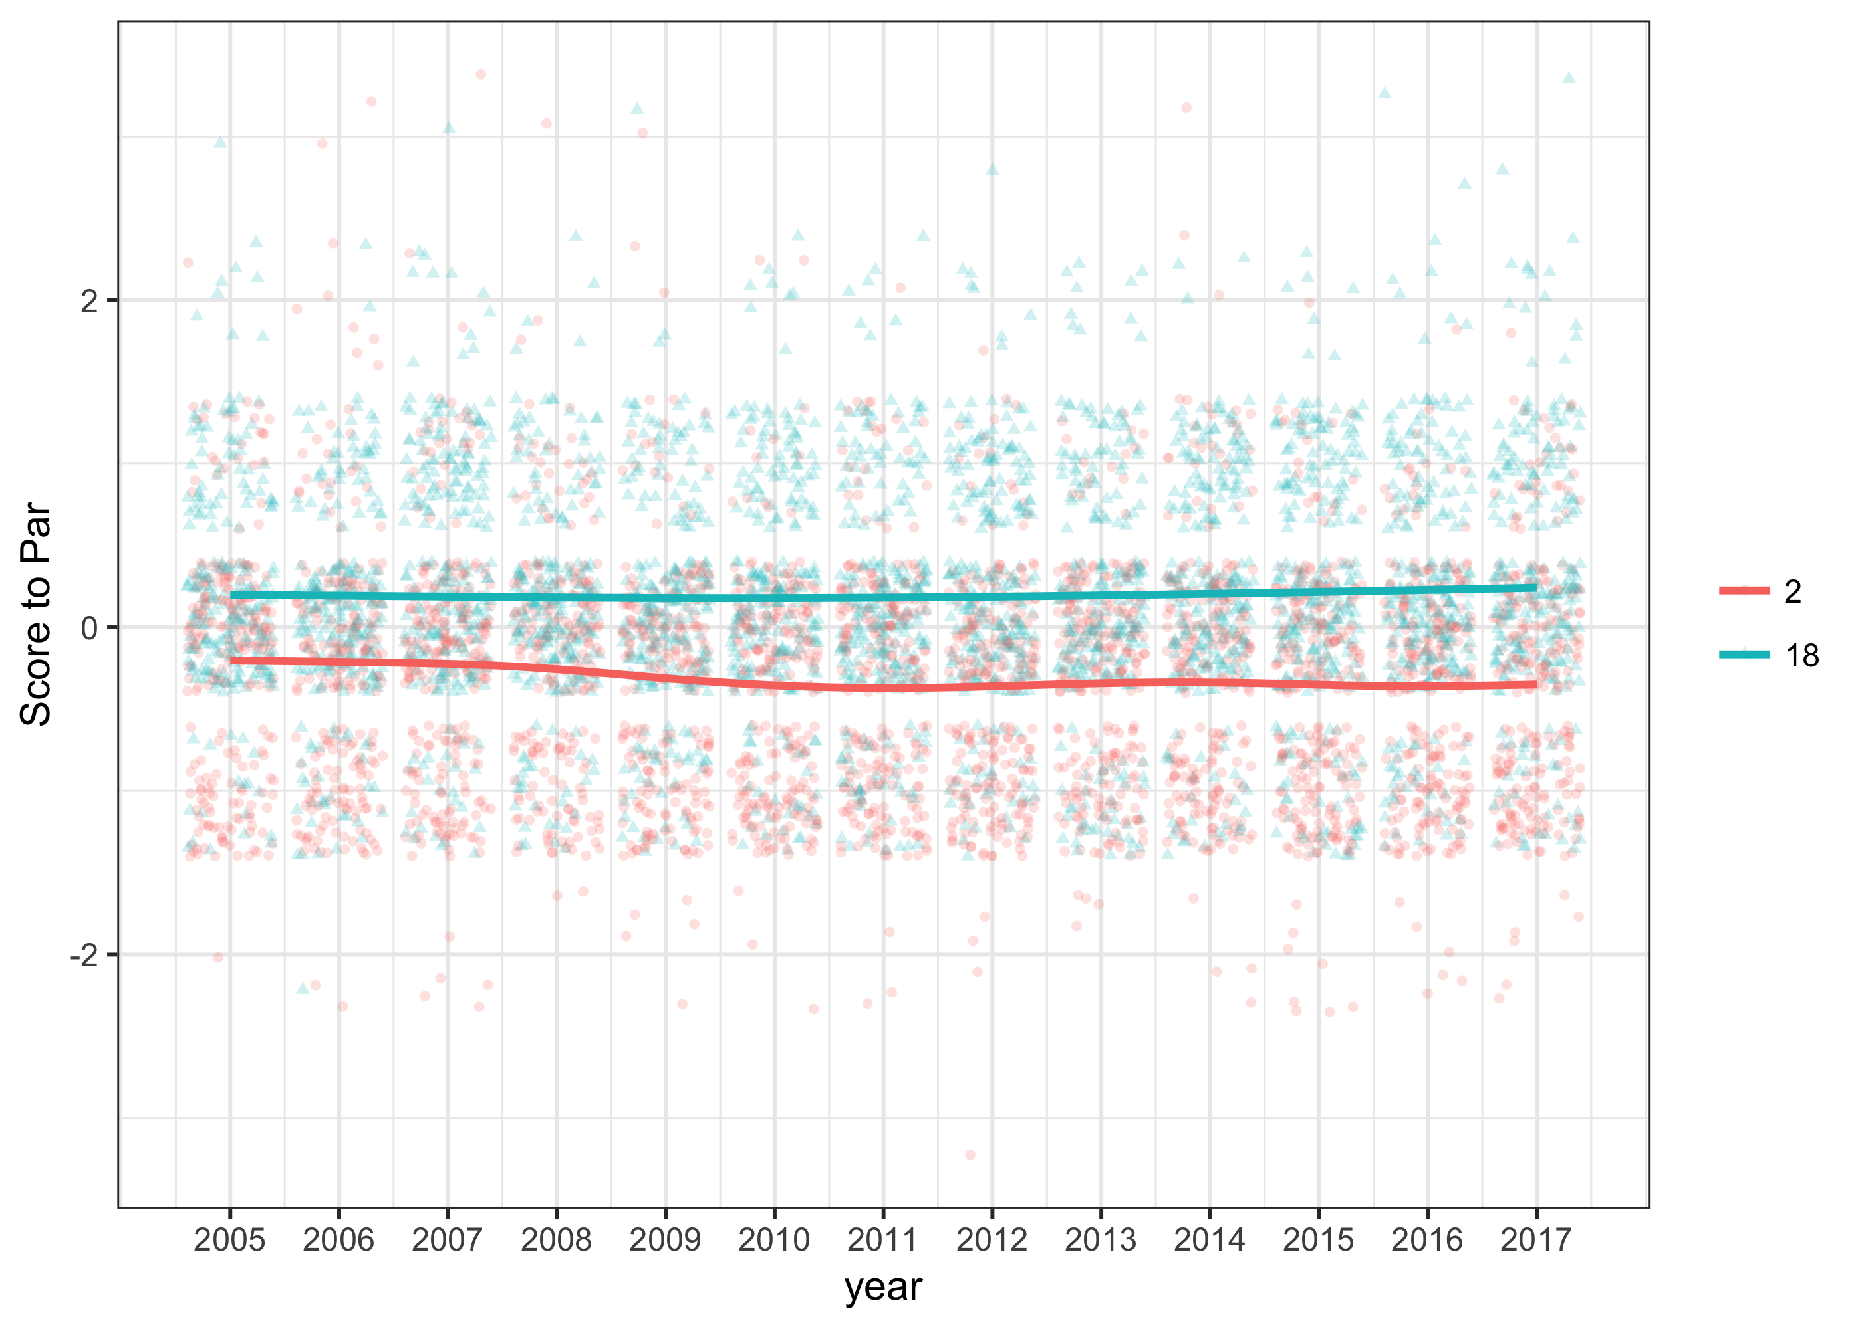

Figure 2. Strokes Gained Data for 2017 Masters. 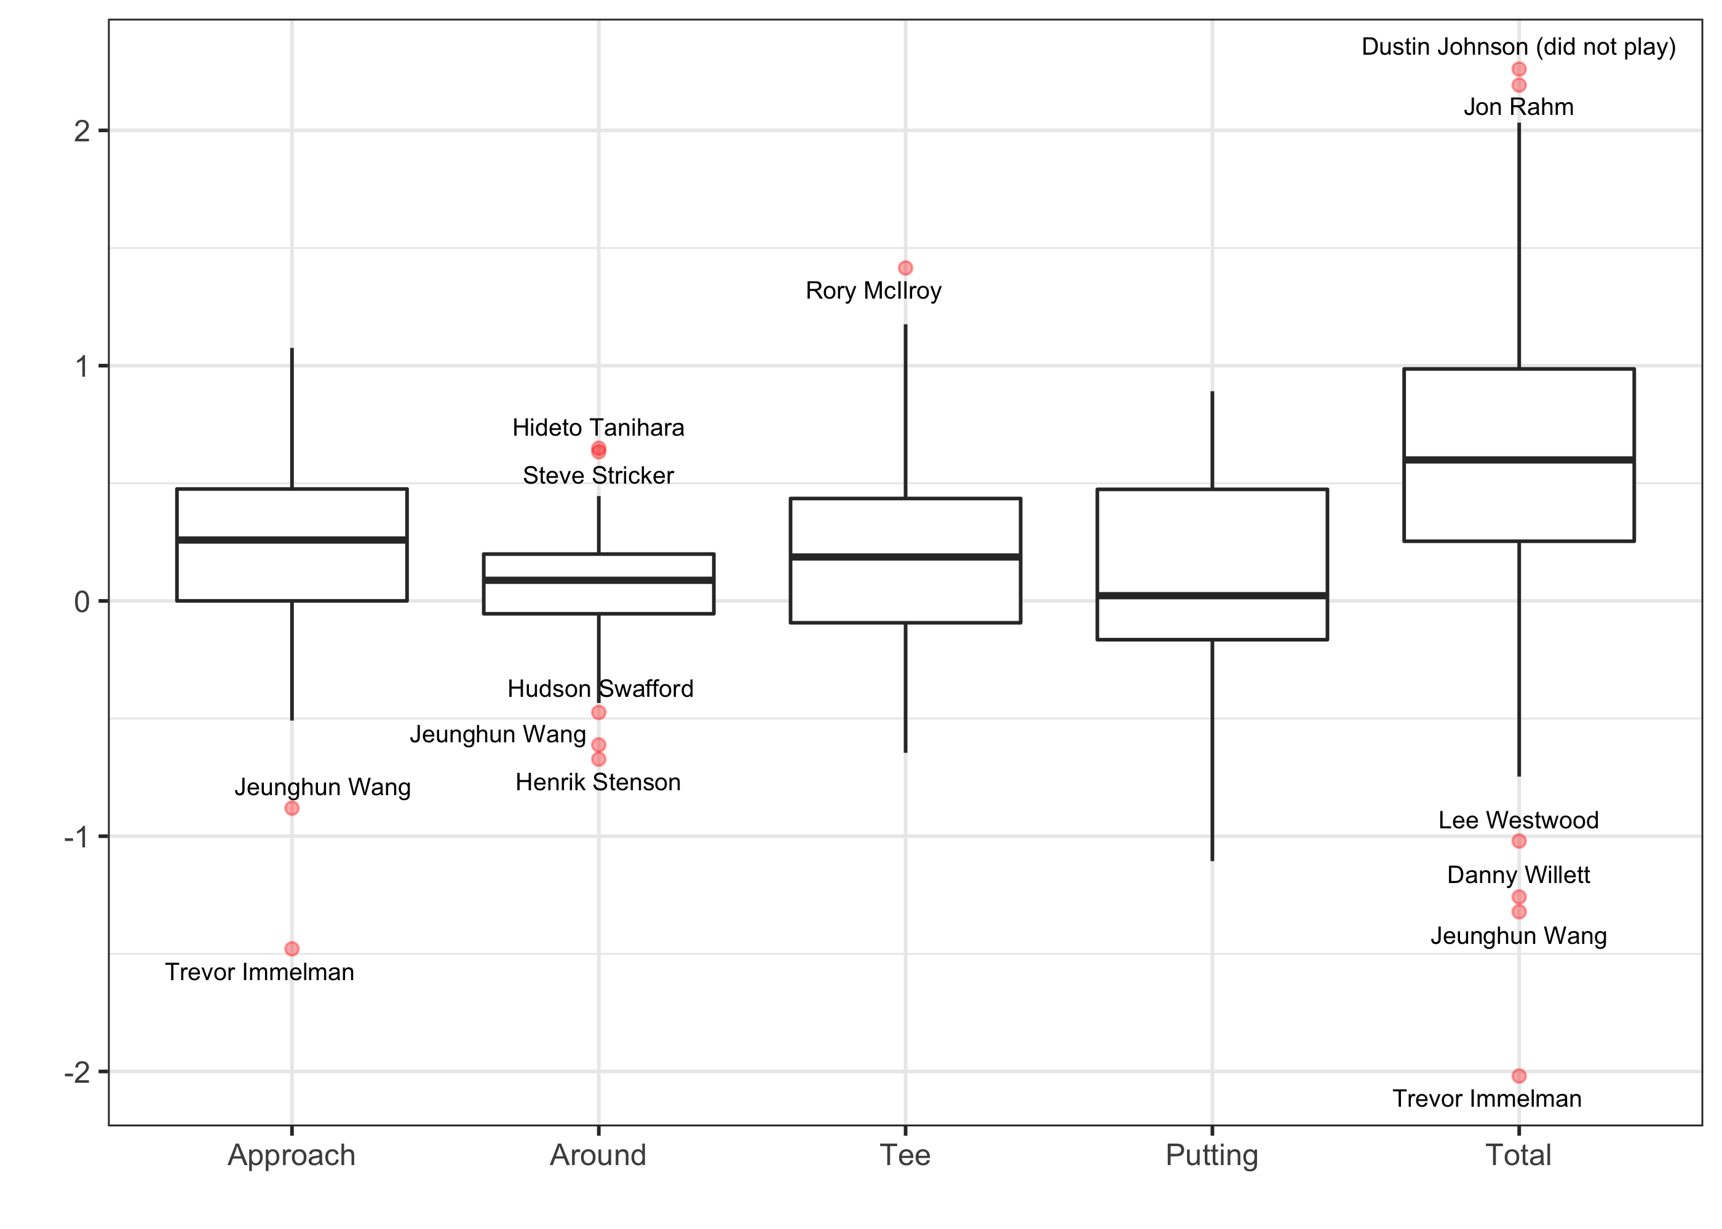

Figure 3. Official World Golf Ranking of 2017 Masters Participants 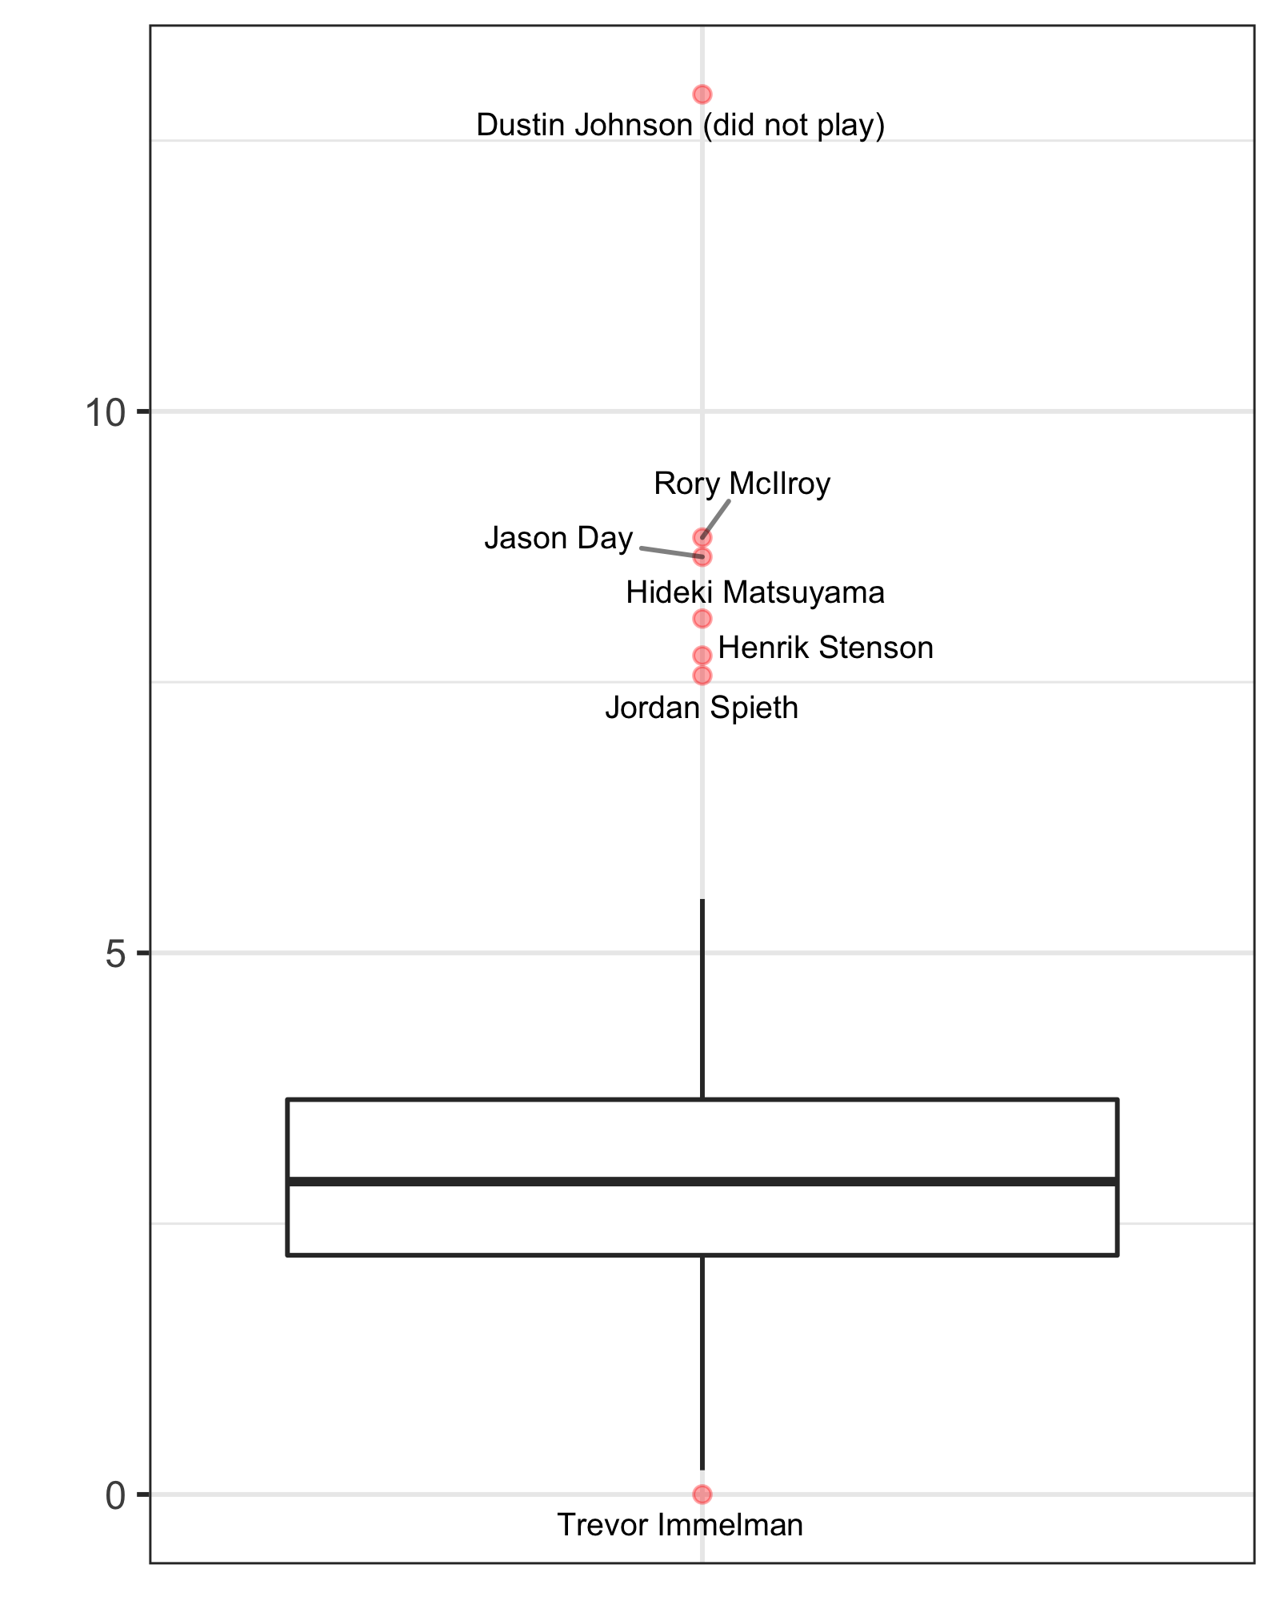

Figure 4a. Random Player Coefficients (histogram) 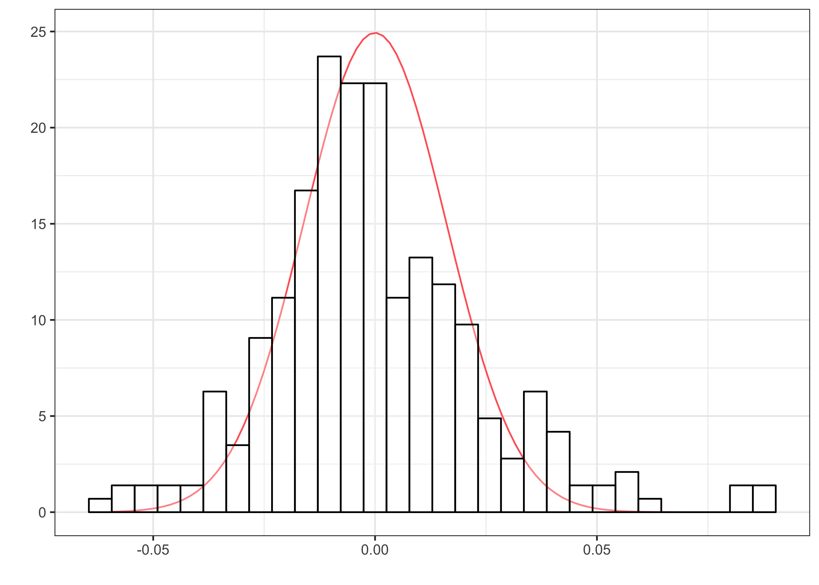

Figure 4b. Random Player Coefficients (boxplot) 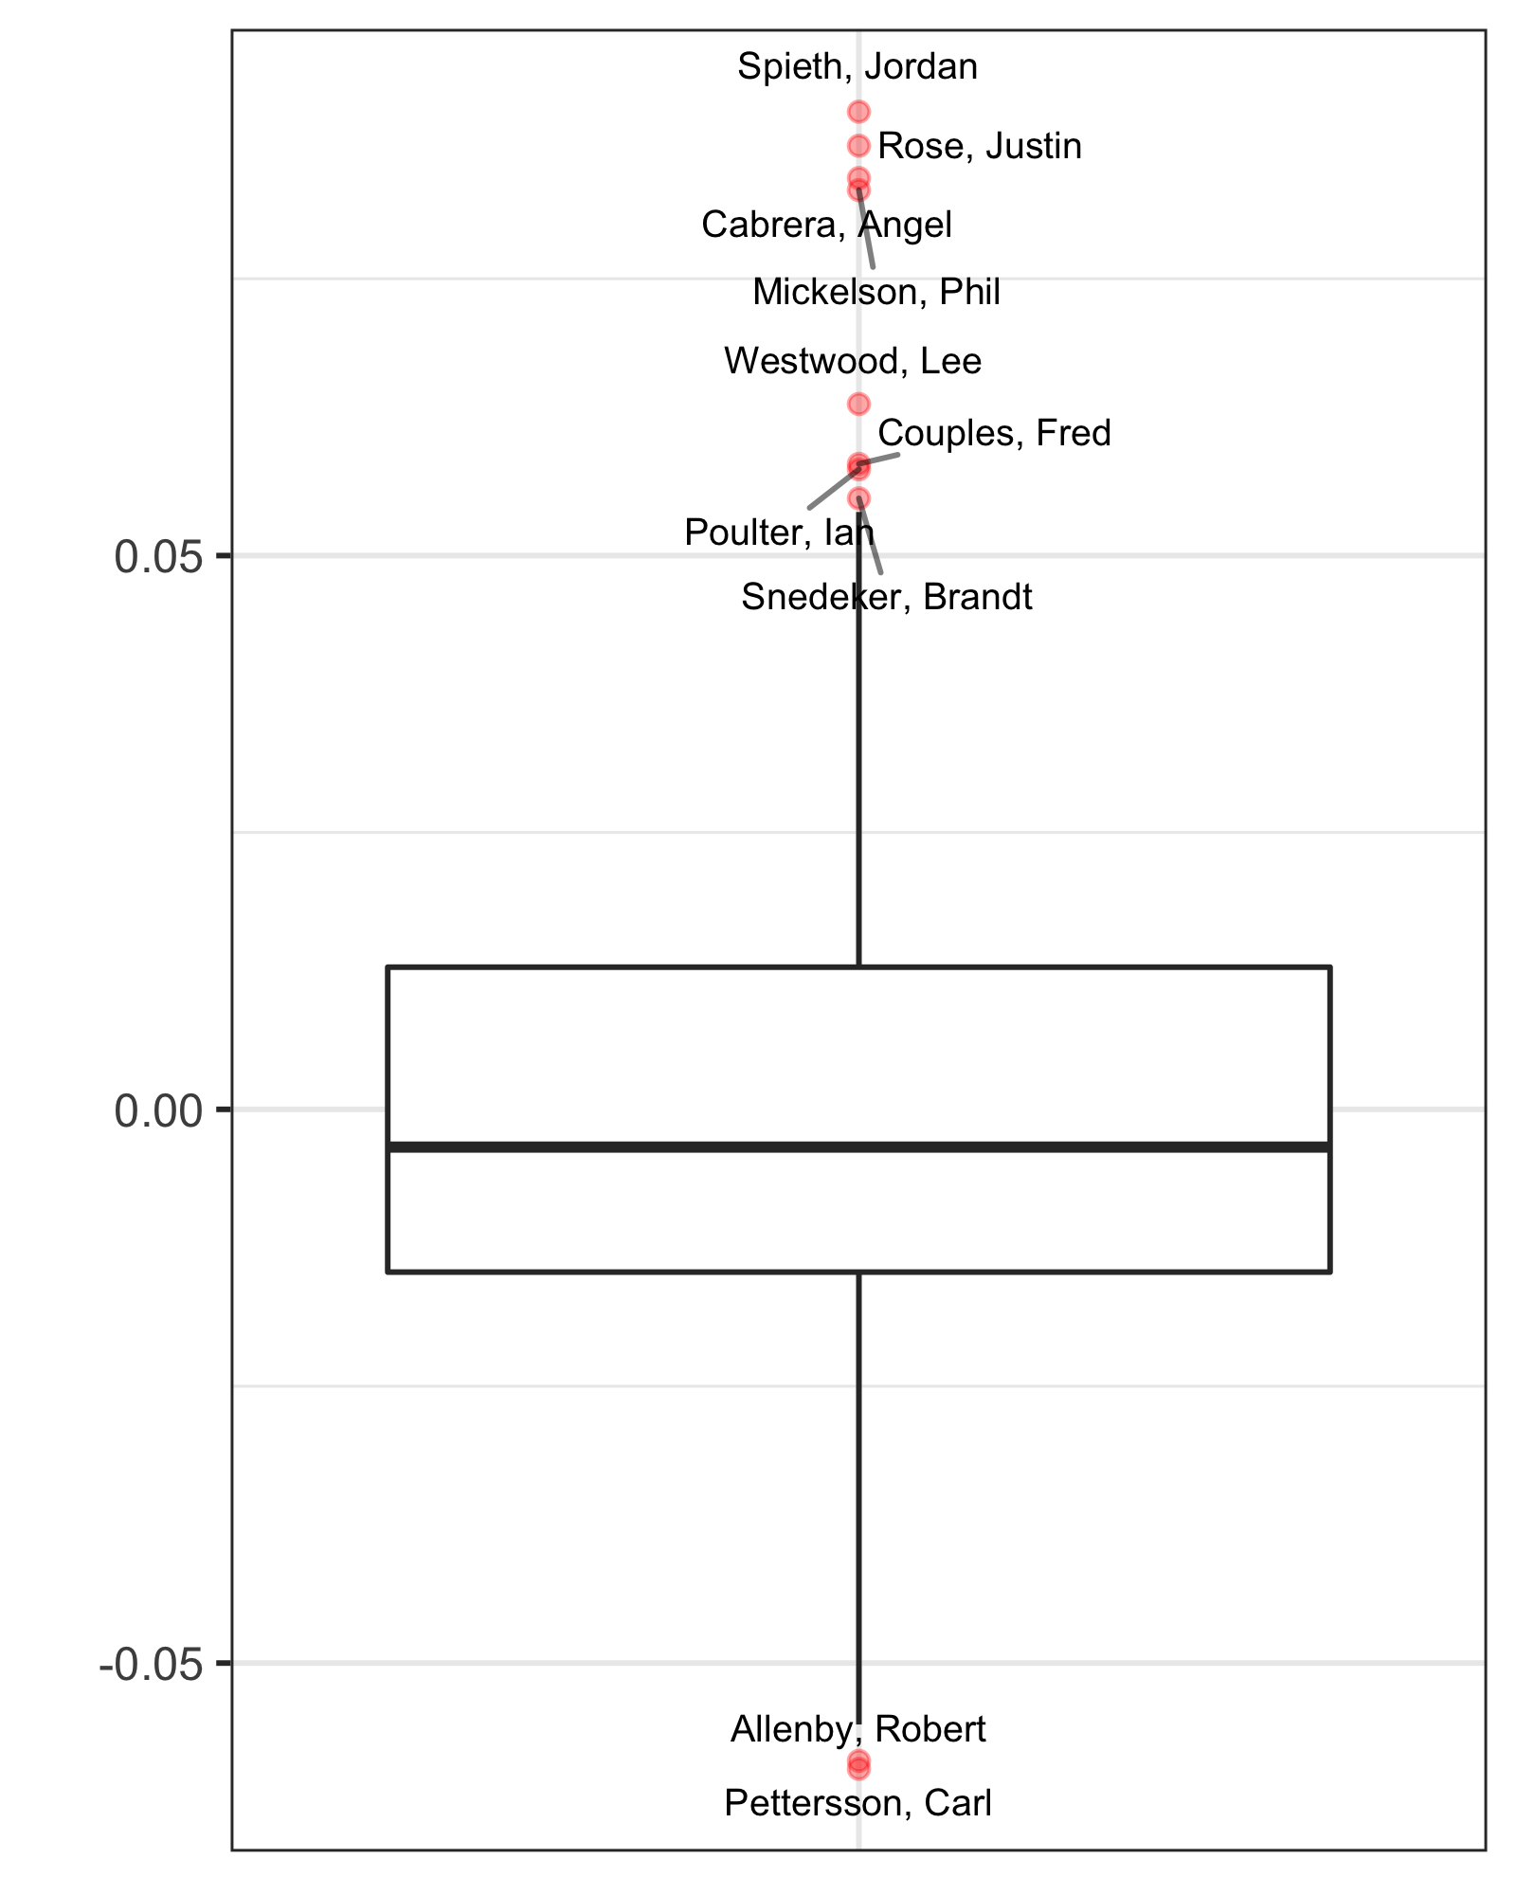

Figure 5. Probability of Winning vs OWGR 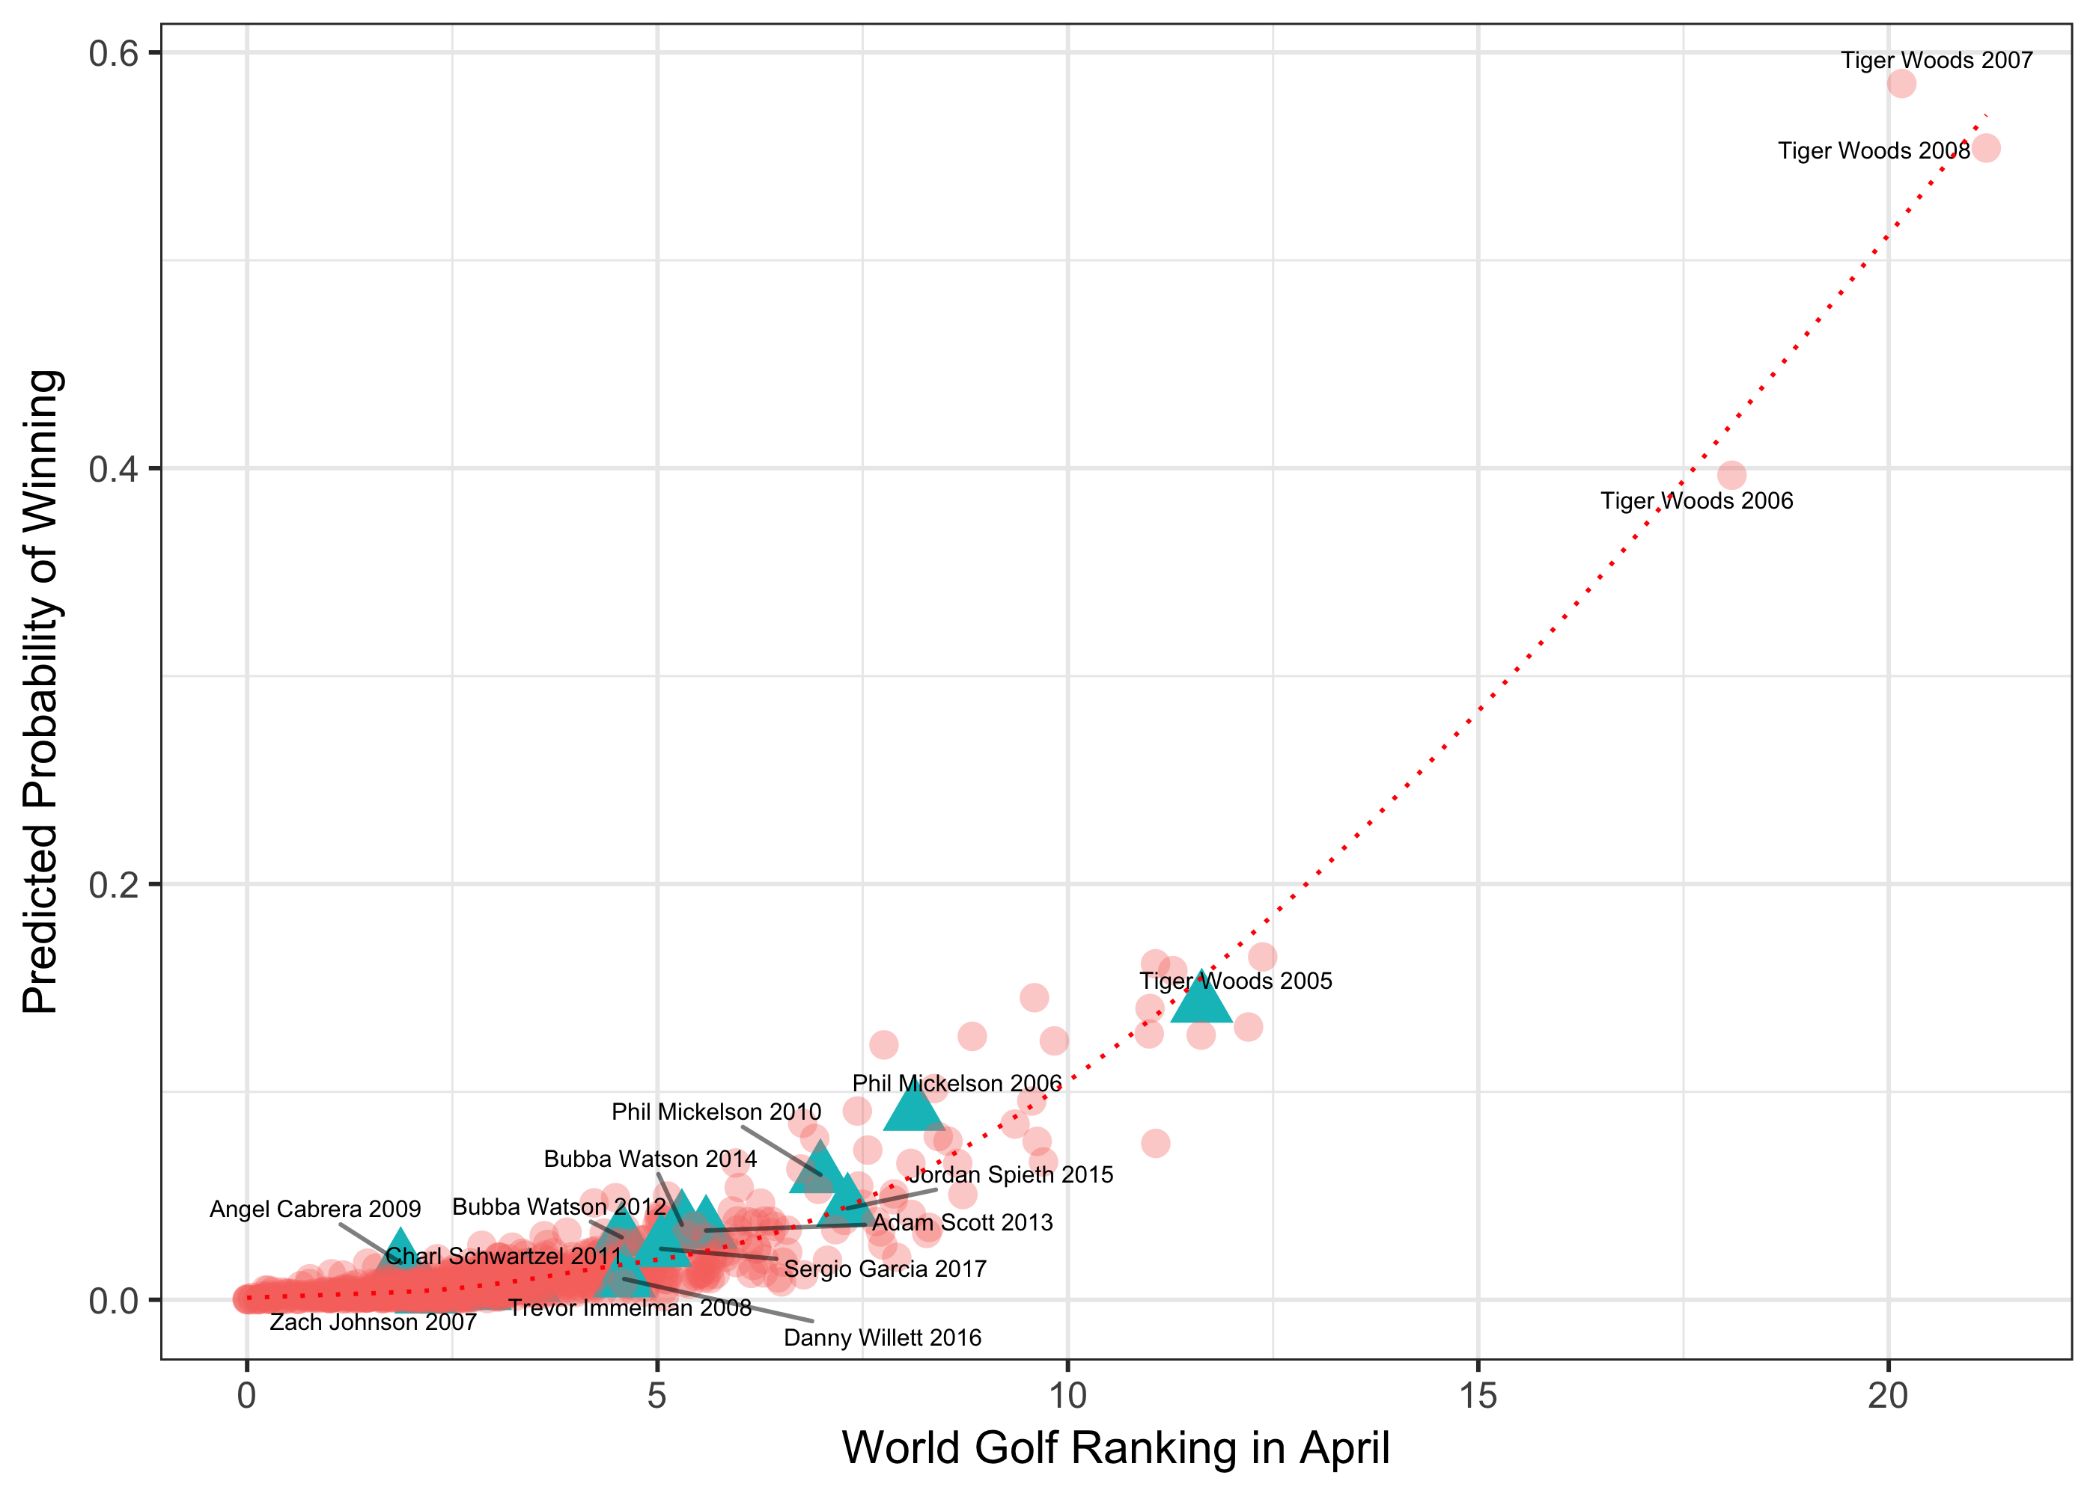

Figure 6. Probability of Winning vs Strokes Gained Total 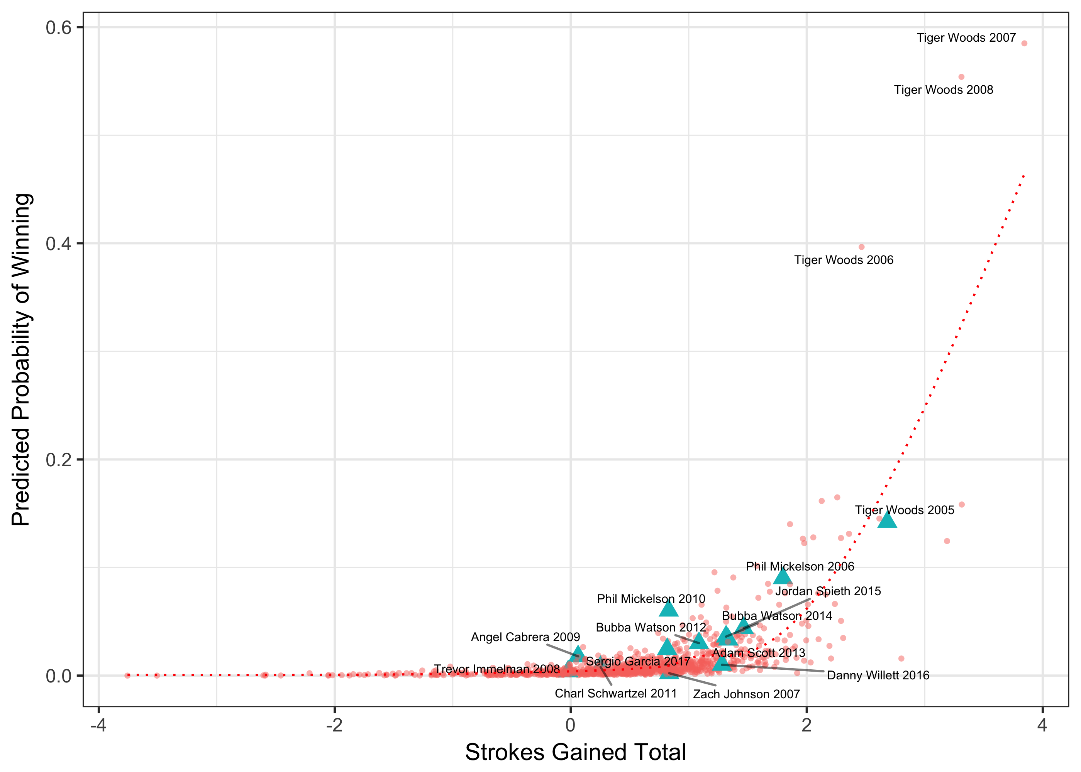

Figure 7. Probability of Winning the Masters: Tiger vs Phil 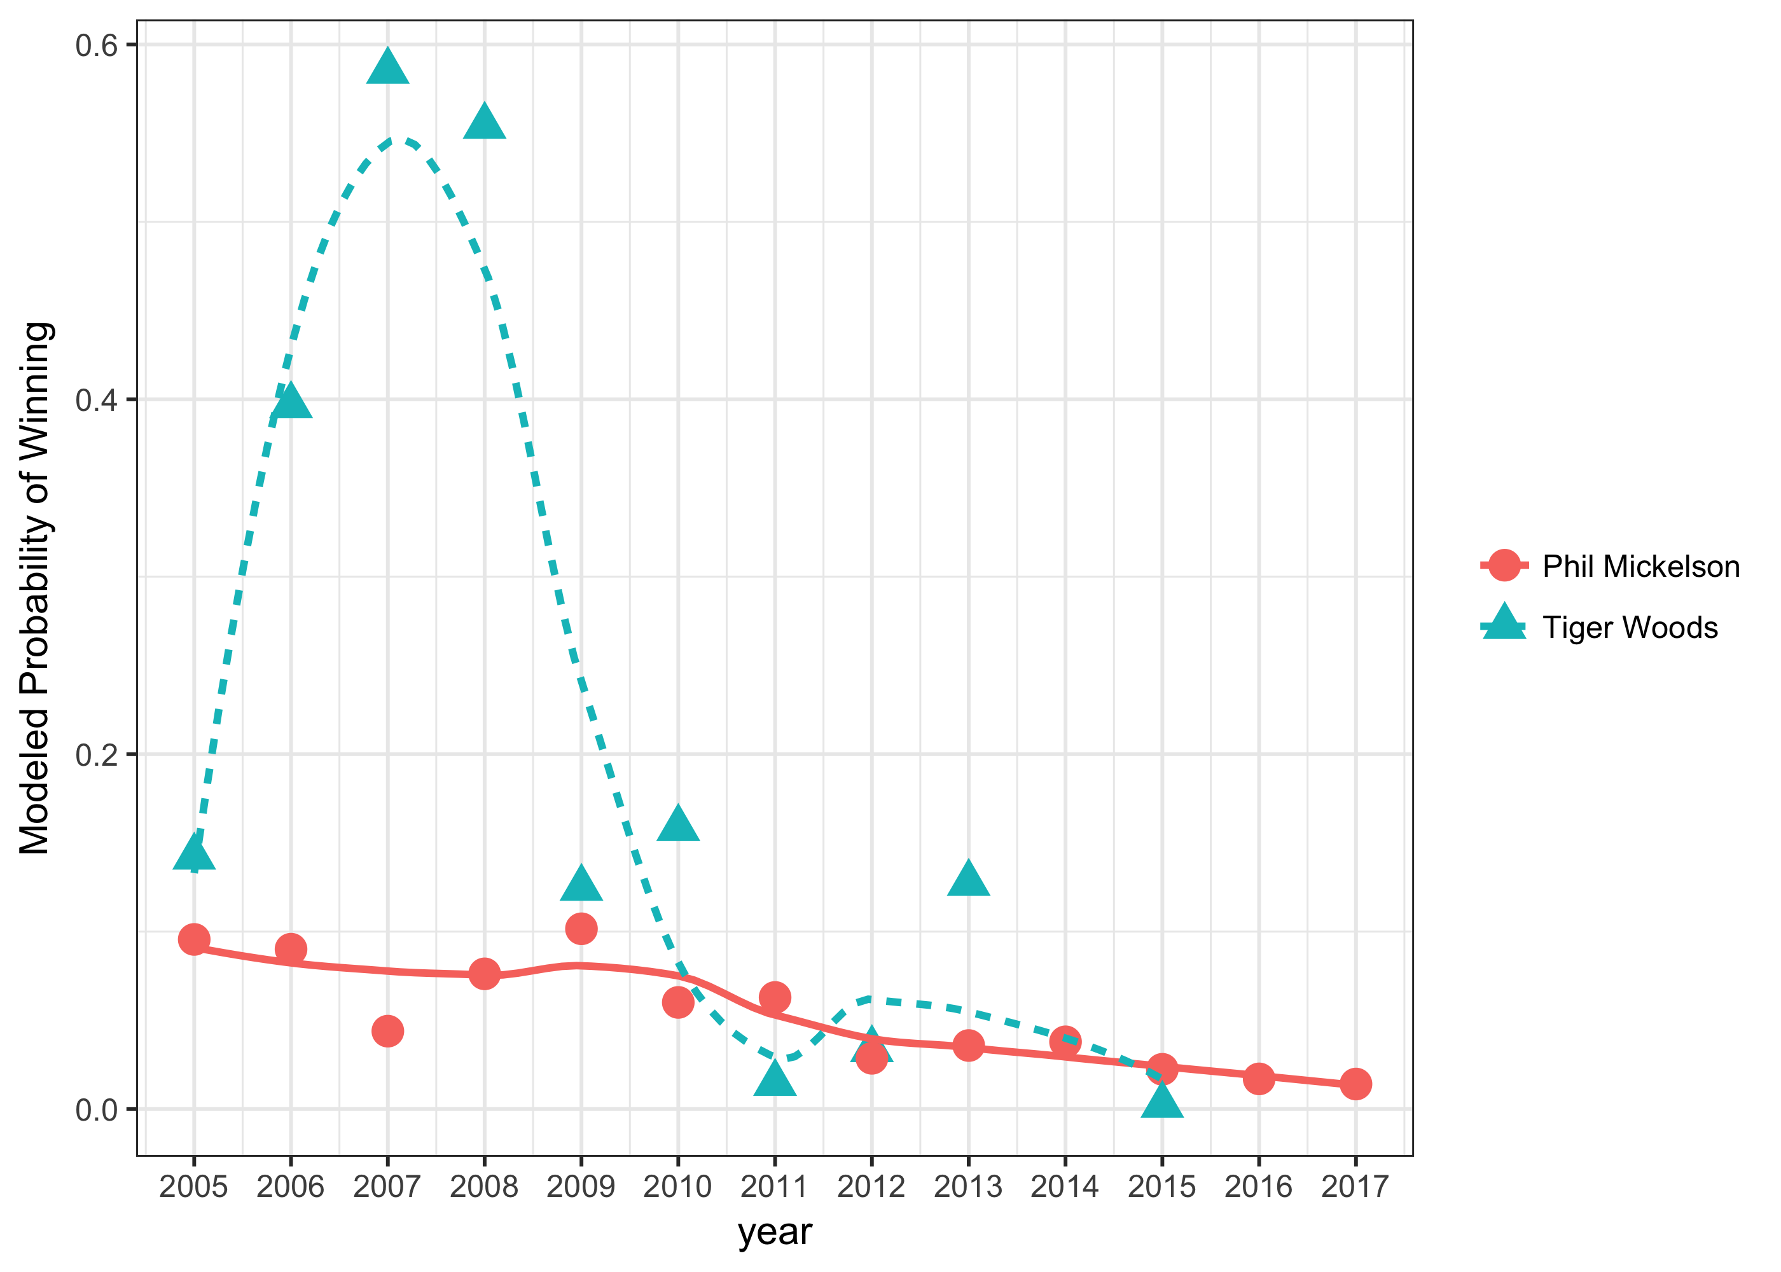

Figure 8: Fixed Effects Estimates by Hole, OWGR = 3 